Photography Meets Art:
Time Traveler Project
Filename: LastName.FirstName.TRAVEL

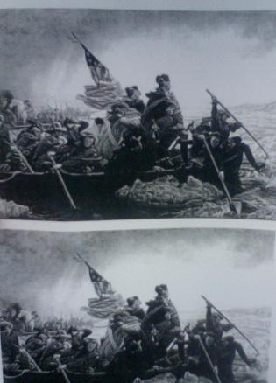
In this project, you will insert a posed and transformed picture of yourself into a famous scene from history. Imagine yourself at the signing of the Declaration of Independence, having tea with Queen Victoria, demonstrating with Martin Luther King, Jr., or in a World War II battle. Your grade will be based on how well you blend into the scene, looking as if you were really there. Costuming is not required, but you should use Photoshop to transform your image to match the picture.

You will use the direct selection tool to crop your image, and the other tools to make your image match. You can either VERY carefully erase your image edges, or use layering to make your image blend into the scene.

