Evocative Emotions Project, PART 2
Goals:
You will
- Write 4 narratives that evoke strong feelings.
- Revise and edit those narratives based on feedback.
- Take and crop 4 pictures of yourself.
- Adjust color levels, hue and saturation to evoke the emotions according to your narratives.
- Arrange the narratives and pictures on a single page.
- Keep all files and images organized in a folder

Part 4: Put your Pictures on a Keynote Slide
- Open Keynote
- Choose a background from the menu
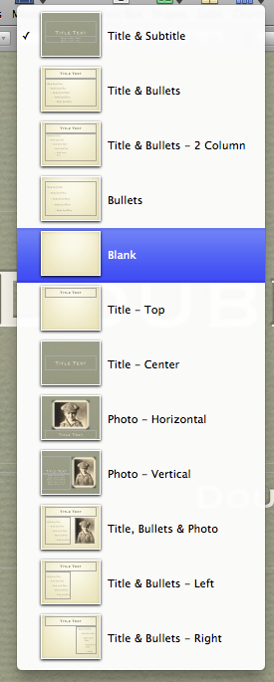
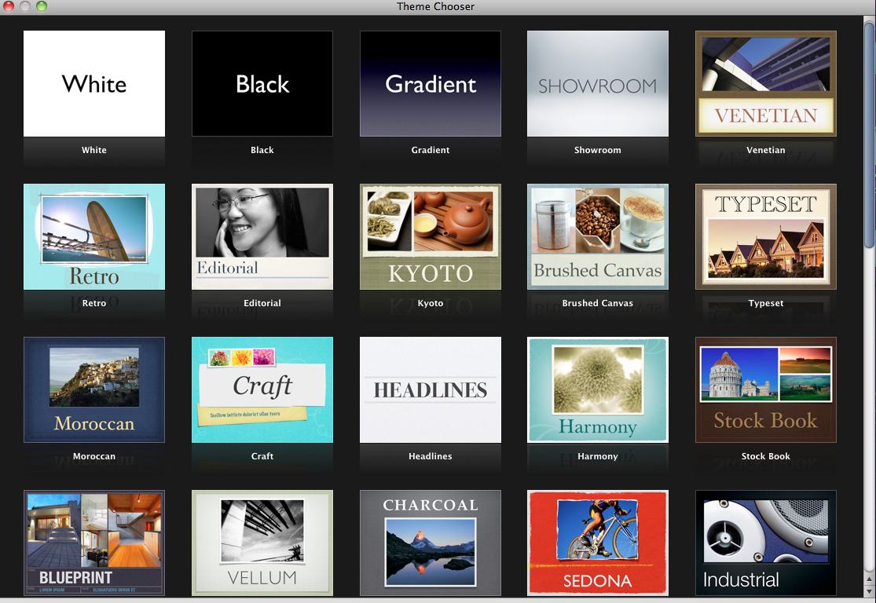
- Click Master , then click Blank.
- Click the inspector button .
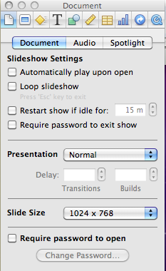
- Set the Slide Size to Custom Slide Size:

- Make the slide size 800 by 1200:

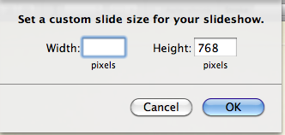
- You may want to set your zoom to fit in window, so you can see the whole slide.
- Insert or drag all 4 of your square pictures onto the slide. Your slide will look very full, and your pictures may overlap.
DO NOT RESIZE THEM!!!
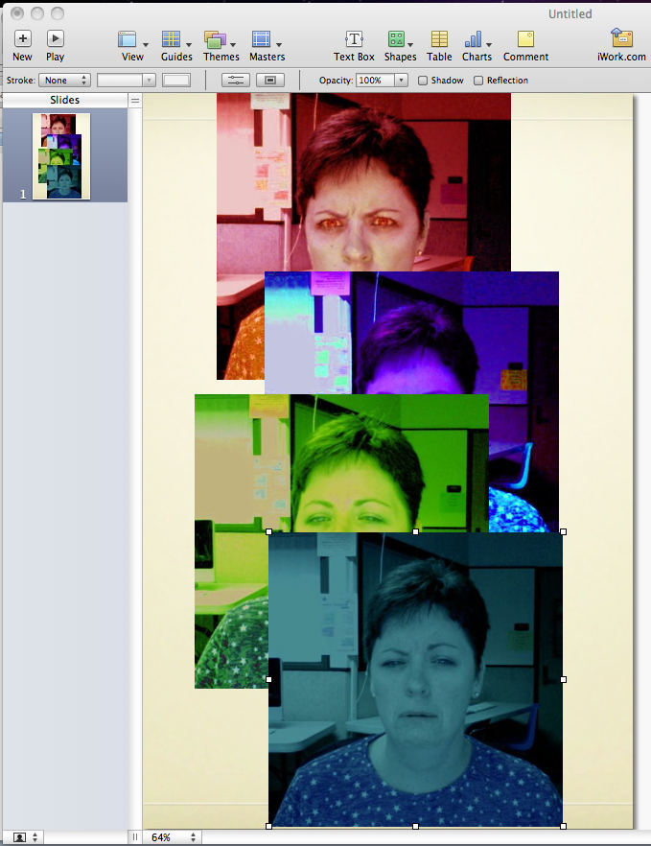

- To make your pictures smaller, you should group and resize them all together. Hold down the shift key and click on all four pictures, or draw a square over them to select them all. Then click Arrange, then click Group.
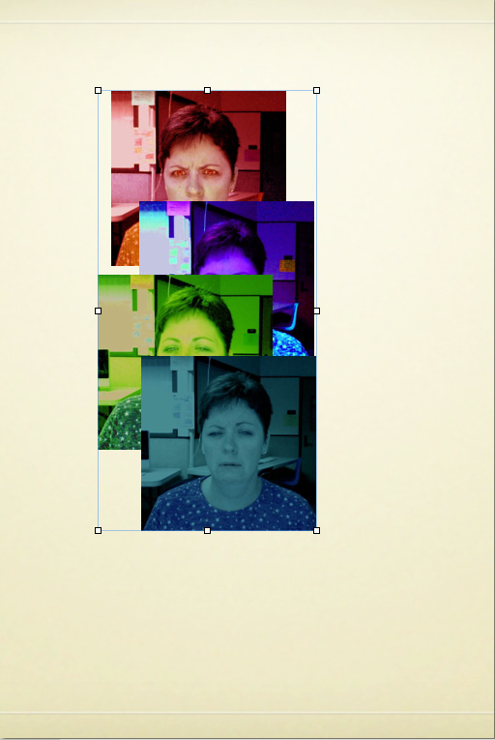
- You will now see a pale box around all of your pictures. Resize this box by pushing the corner handles. Make the pictures small enough to make room on your slide for your stories. Then click Arrange, Ungroup.

- Now drag your pictures to the four quadrants of your slide. Leave a little background showing at the top and between the slides. As you drag them around, you will see yellow grid lines appear when your pictures are in line with each other.

Part 5: Put your Narratives on the Keynote Slide
- Open your Draft of your narratives. Make the window small enough to push over to the side. Highlight your first narrative, and type command and C, or click edit- copy.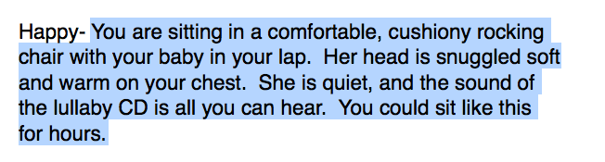
- Click Text Box.. A textbox will appear in the center of your slide.

- Double-Click in this text box, and then type command V or click edit- paste. Your story should appear in the text box:
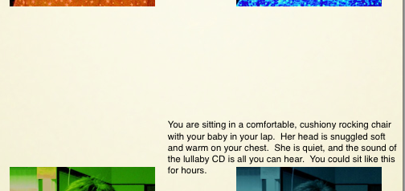

- Use the Colors and Fonts Buttons to make your story the style you like, that matches your picture.
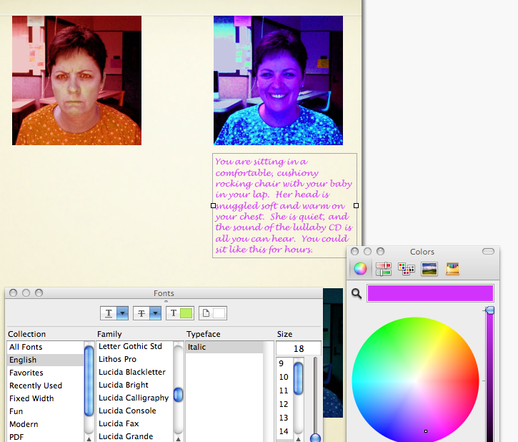
- Drag your narrative text box so that it is UNDER the picture it goes with. Use the side handles to make it fit. You can also resize your pictures, but remember to group them, so they are all the same size, then ungroup them (see Part 4 Step 9)

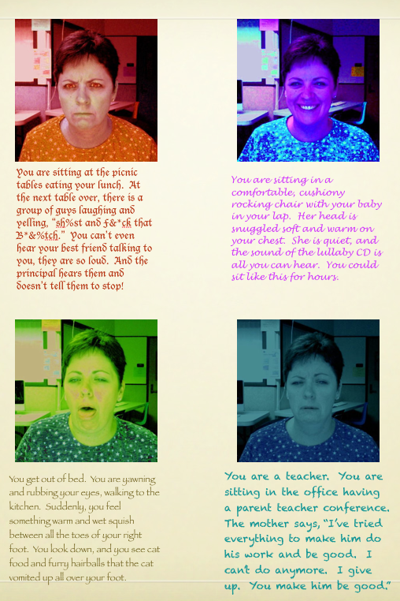
- Repeat steps 2-5 for each narrative, so that all 4 pictures have the narrative that evokes the emotion under it. Make sure that everything fits on the one slide.

- Click File- Save. Name this file LastName.FirstName.EMOTIONS. Save it to the desktop and then drag it to your folder.

- Then click File- Export. You will see this:
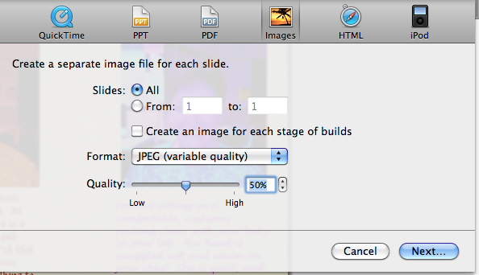

- Click Next. Now you will see this:
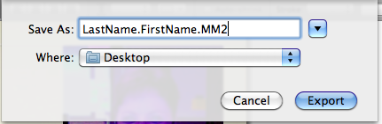
Name your file and set the WHERE to desktop. Click Export.

- Drag this new exported jpeg to the drop folder to turn it in. DO NOT TURN IN THE KEYNOTE FILE.

